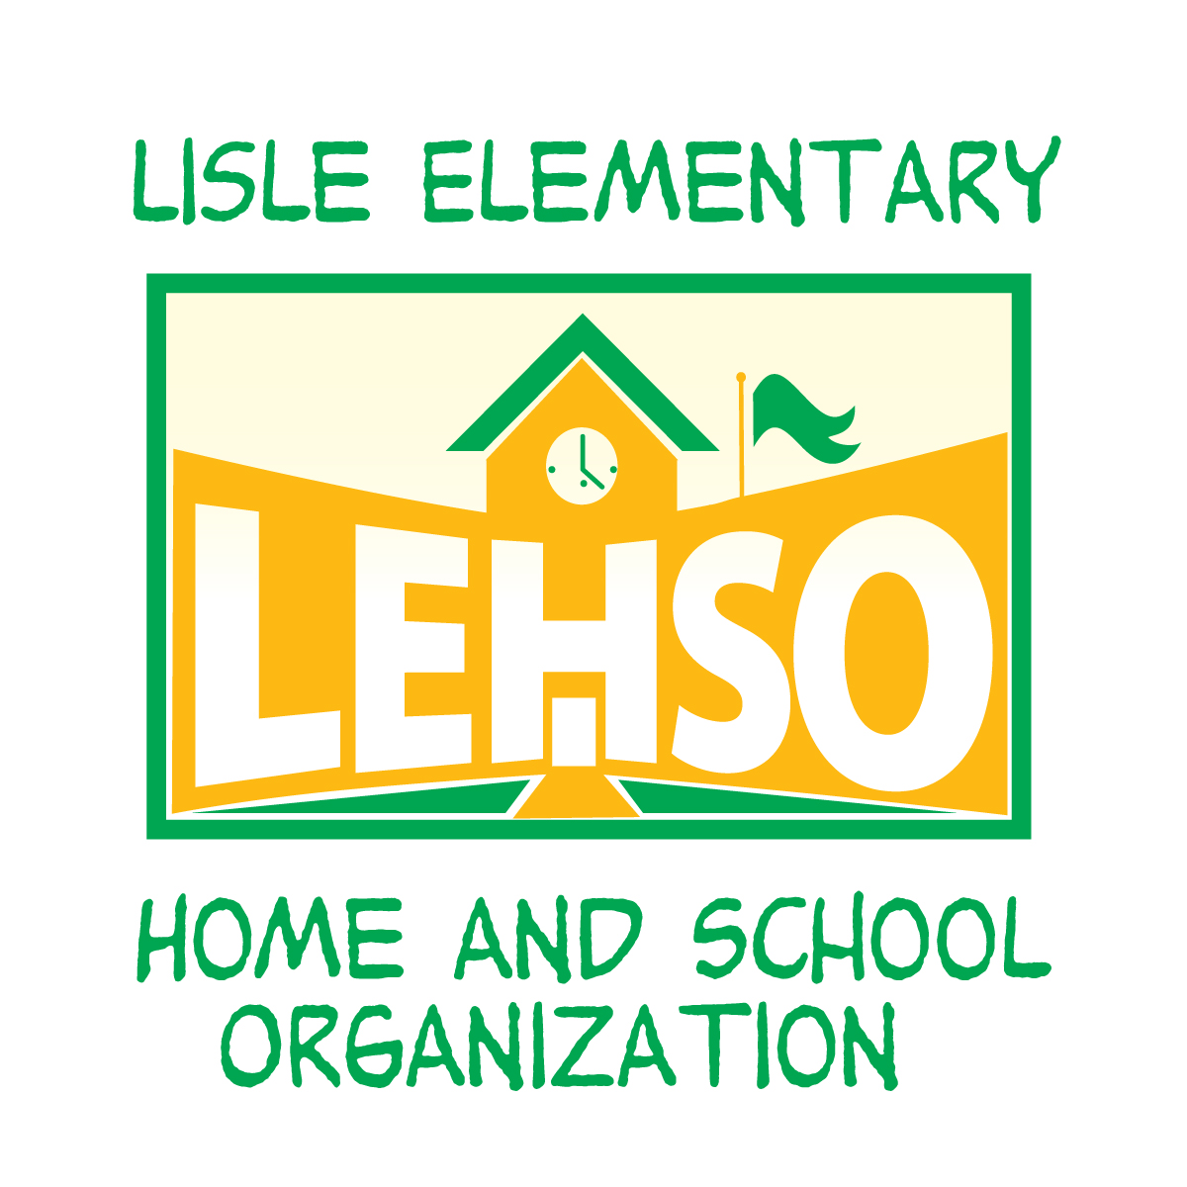

We Need Your Help!
Volunteer at the LEHSO Clothing & Toy Resale

Our Spring/Summer 2020 Clothing & Toy Resale will be held on Saturday, March 7th at 5205 Kingston Ave (formerly Scheisher School). Our Clothing Resales are our largest fundraisers for the LEHSO. Even one hour of help with any of the following jobs will help us make this event a success. This is a 100% volunteer-run event.

Also, with a two-hour shift you get to pre-shop our resale on Friday, March 6th from 6:30-8:30!

SET UP OF RACKS AND TABLES
Wednesday, March 4th 5:30pm-7:30pm
Help out with setting up the clothing racks and tables. Tape down the seller numbers to the floors where we put unsold items after the sale.

CHECK IN OF SELLER ITEMS
Wednesday, March 4th & Thursday, March 5th 5:00pm-9:30pm
This involves checking each item the sellers bring in to make sure they are on our approved list of sellable items, are not stained or are not broken.

DISTRIBUTION OF SELLER ITEMS TO SALES FLOOR
Wednesday, March 4th & Thursday, March 5th 5:00 p.m. – 9:30pm
This involves taking the approved items for sale and putting them in the correct place throughout the gym.

BREAK DOWN
Saturday, March 7th 2:30 – 4:30 p.m.
This involves putting the unsold items in order based on seller number and putting away the tables and racks.

How do I signup to volunteer or sell?
VOLUNTEER: Simply email us at LisleResale@LEHSO.org to let us know when you are able to volunteer or sign up at lehso.org/volunteer.

SELL: Email us at LisleResale@LEHSO.org for more information on selling. You keep 70% of your profit and the LEHSO keeps 30%.

